Communications Plan

Gran Paradiso, Venice, FL

# Overview/Purpose

This plan provides for emergency communications both internal and external to the Gran Paradiso community in times of disaster; before, during and after an event; and with total loss of power and infrastructure.

The plan provides the capability for Incident Command to:

* communicate internally to pertinent command team leaders using a dedicated radio repeater system while sub teams communicate using talkies directly between members, radio-to-radio (simplex).
* use cell phones or landlines, if available, for external communications
* pass emergency traffic externally via ham radio to the North Port EOC, Sarasota EOC, others as identified, or beyond, as necessary, via ham radio stations located either within Gran Paradiso or Island Walk (future - within surrounding West Villages communities).

Although not specifically used by GP CERT at this time, the communications team will pursue the future use and applicability of the Emergency Service Network “FirstNet” (special hardened cell phone system). It is generally available to police, fire, EMS and CERT as a system to connect first responders.

# Communications Plan Activation

In consultation with the Incident Commander (IC) the Communication Team will activate the repeater and ready the Incident Command Center communications station.

Before an event the repeater may (most probably will) be activated and tested to ensure that it is operational. All CERT members with CERT supplied or personal radios are encouraged to test their radios.

Once the Incident Commander activates GP CERT the Communications Team will set up a communications station at the Incident Command Center including:

* Establish an operational area staffed by a Dispatcher *(Note: Dispatcher will establish a dispatcher schedule in 4 – 6 hour shifts)*
* Set up power generation for communications equipment as available
* Put spare talkies and batteries on charge *(Note: spare talkies will be used as Zone Leader replacements should their talkie batteries discharge or otherwise malfunction and for any use required by the IC)*
* Check availability of telephone service (cell phones or landlines)
* Ready documents and forms for communication use
  + Emergency phone numbers and contact list
    - GP CERT team members (all, internal)
    - External contact list
    - GP CERT internal Zones & Frequencies map
  + CERT communications related forms
    - ICS 213 General Message form (message for delivery)
    - ICS 309 Communications Log (track messages sent/received)
    - ICS 303 Equipment Inventory (track communications equipment)
    - ICS 205 Incident Radio Communications Plan (for reference)
* Check readiness of Zones via radio
* Check readiness of ham radio stations
* Check readiness of Island Walk via simplex and repeater
* Report readiness to the Incident Commander
* Upon completion of CERT activity
  + the Dispatcher will collect and deliver data to the IC, and return communications materials (radios, chargers, forms, etc.) to storage
  + The Communications Team will de-activate the repeater

# Use of GP CERT radios

Talkies and chargers, provided by GP CERT to Zone Leaders and others as required shall be well maintained and charged at all times by those to whom they were assigned. These talkies use Lithium batteries and should maintain power for months. However, it is the responsibility of the assignee of each radio to periodically put it on charge such that each talkie is ready for use at all times.

Zone leaders should arrange to make their talkie available to another team member when they expect to be absent for emergency operations or exercises.

GP CERT radios should only be used for CERT activities and not for personal use.

# Use of personal radios for GP CERT activities

As GP CERT does not have the resources to provide talkies to all team members, individual team members are encouraged to purchase FRS/GRMS radios at their expense, program them to their zone frequencies and use them for CERT activities. See the Frequencies Chart later in this document to progam personal radios (not Retevis talkies) to your Zone Team frequency.

Ham radio stations are encouraged to purchase repeater-ready GMRS radios to be able to communications with the Incident Command Dispatcher. CERT has spare Retevis radios that can be assigned to hams in emergencies.

# Use of GP CERT repeater

The repeater will only be activated for emergency or exercise purposes. When activated it should only be used for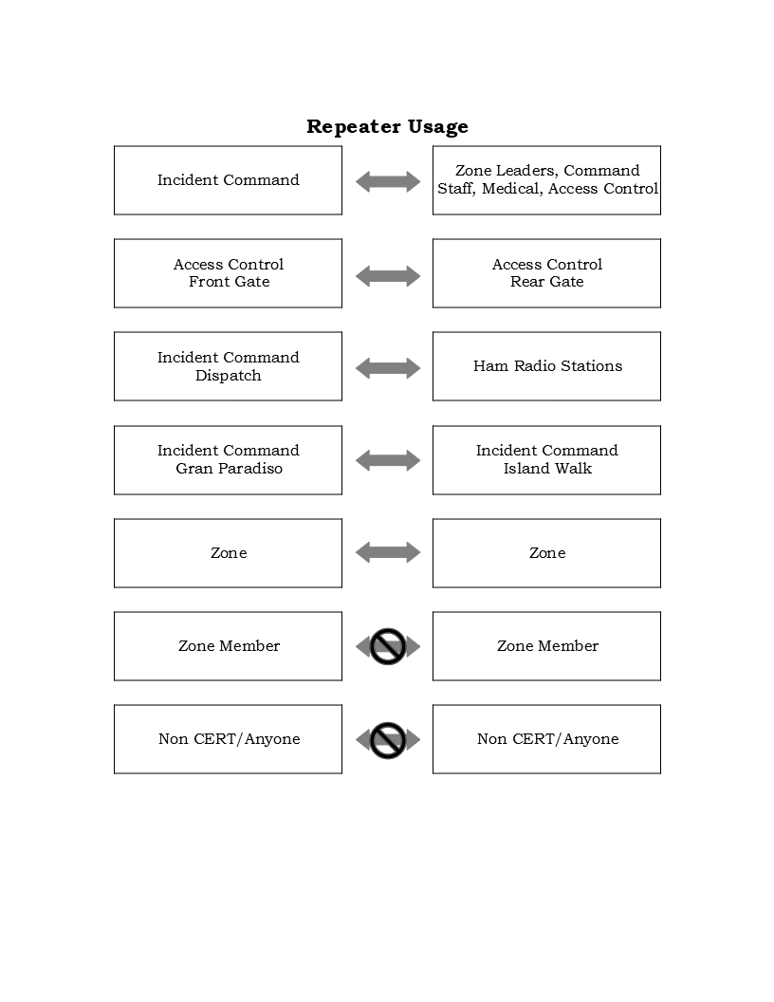:

* **Incident Command to Zone Leaders, Command Staff, Medical, Access Control**
  + Emergency traffic, Command instructions, status
* **Access Control front gate to Access Control rear gate**
  + IC permission required; general traffic, direction, status, *when talkie-to-talkie comms are unreliable*
* **Incident Command/Dispatch to Ham Radio Stations**
  + Emergency traffic external to Gran Paradiso
* **Incident Command Gran Paradiso to Incident Command Island Walk**
  + Assistance, status, information
* **Zone to Zone**
  + IC permission required; when need to request/pass time sensitive information
* **Zone Team Member/Anyone to Zone Team Member/Anyone**
  + Not permitted
* **Non CERT/Anyone to Non CERT/Anyone**
  + Not permitted

# Community Communications Sharing

This graphic depicts how communication occur within and without the community. When necessary, communications to external resources, other than participating GMRS communities will be via licensed ham radio stations.

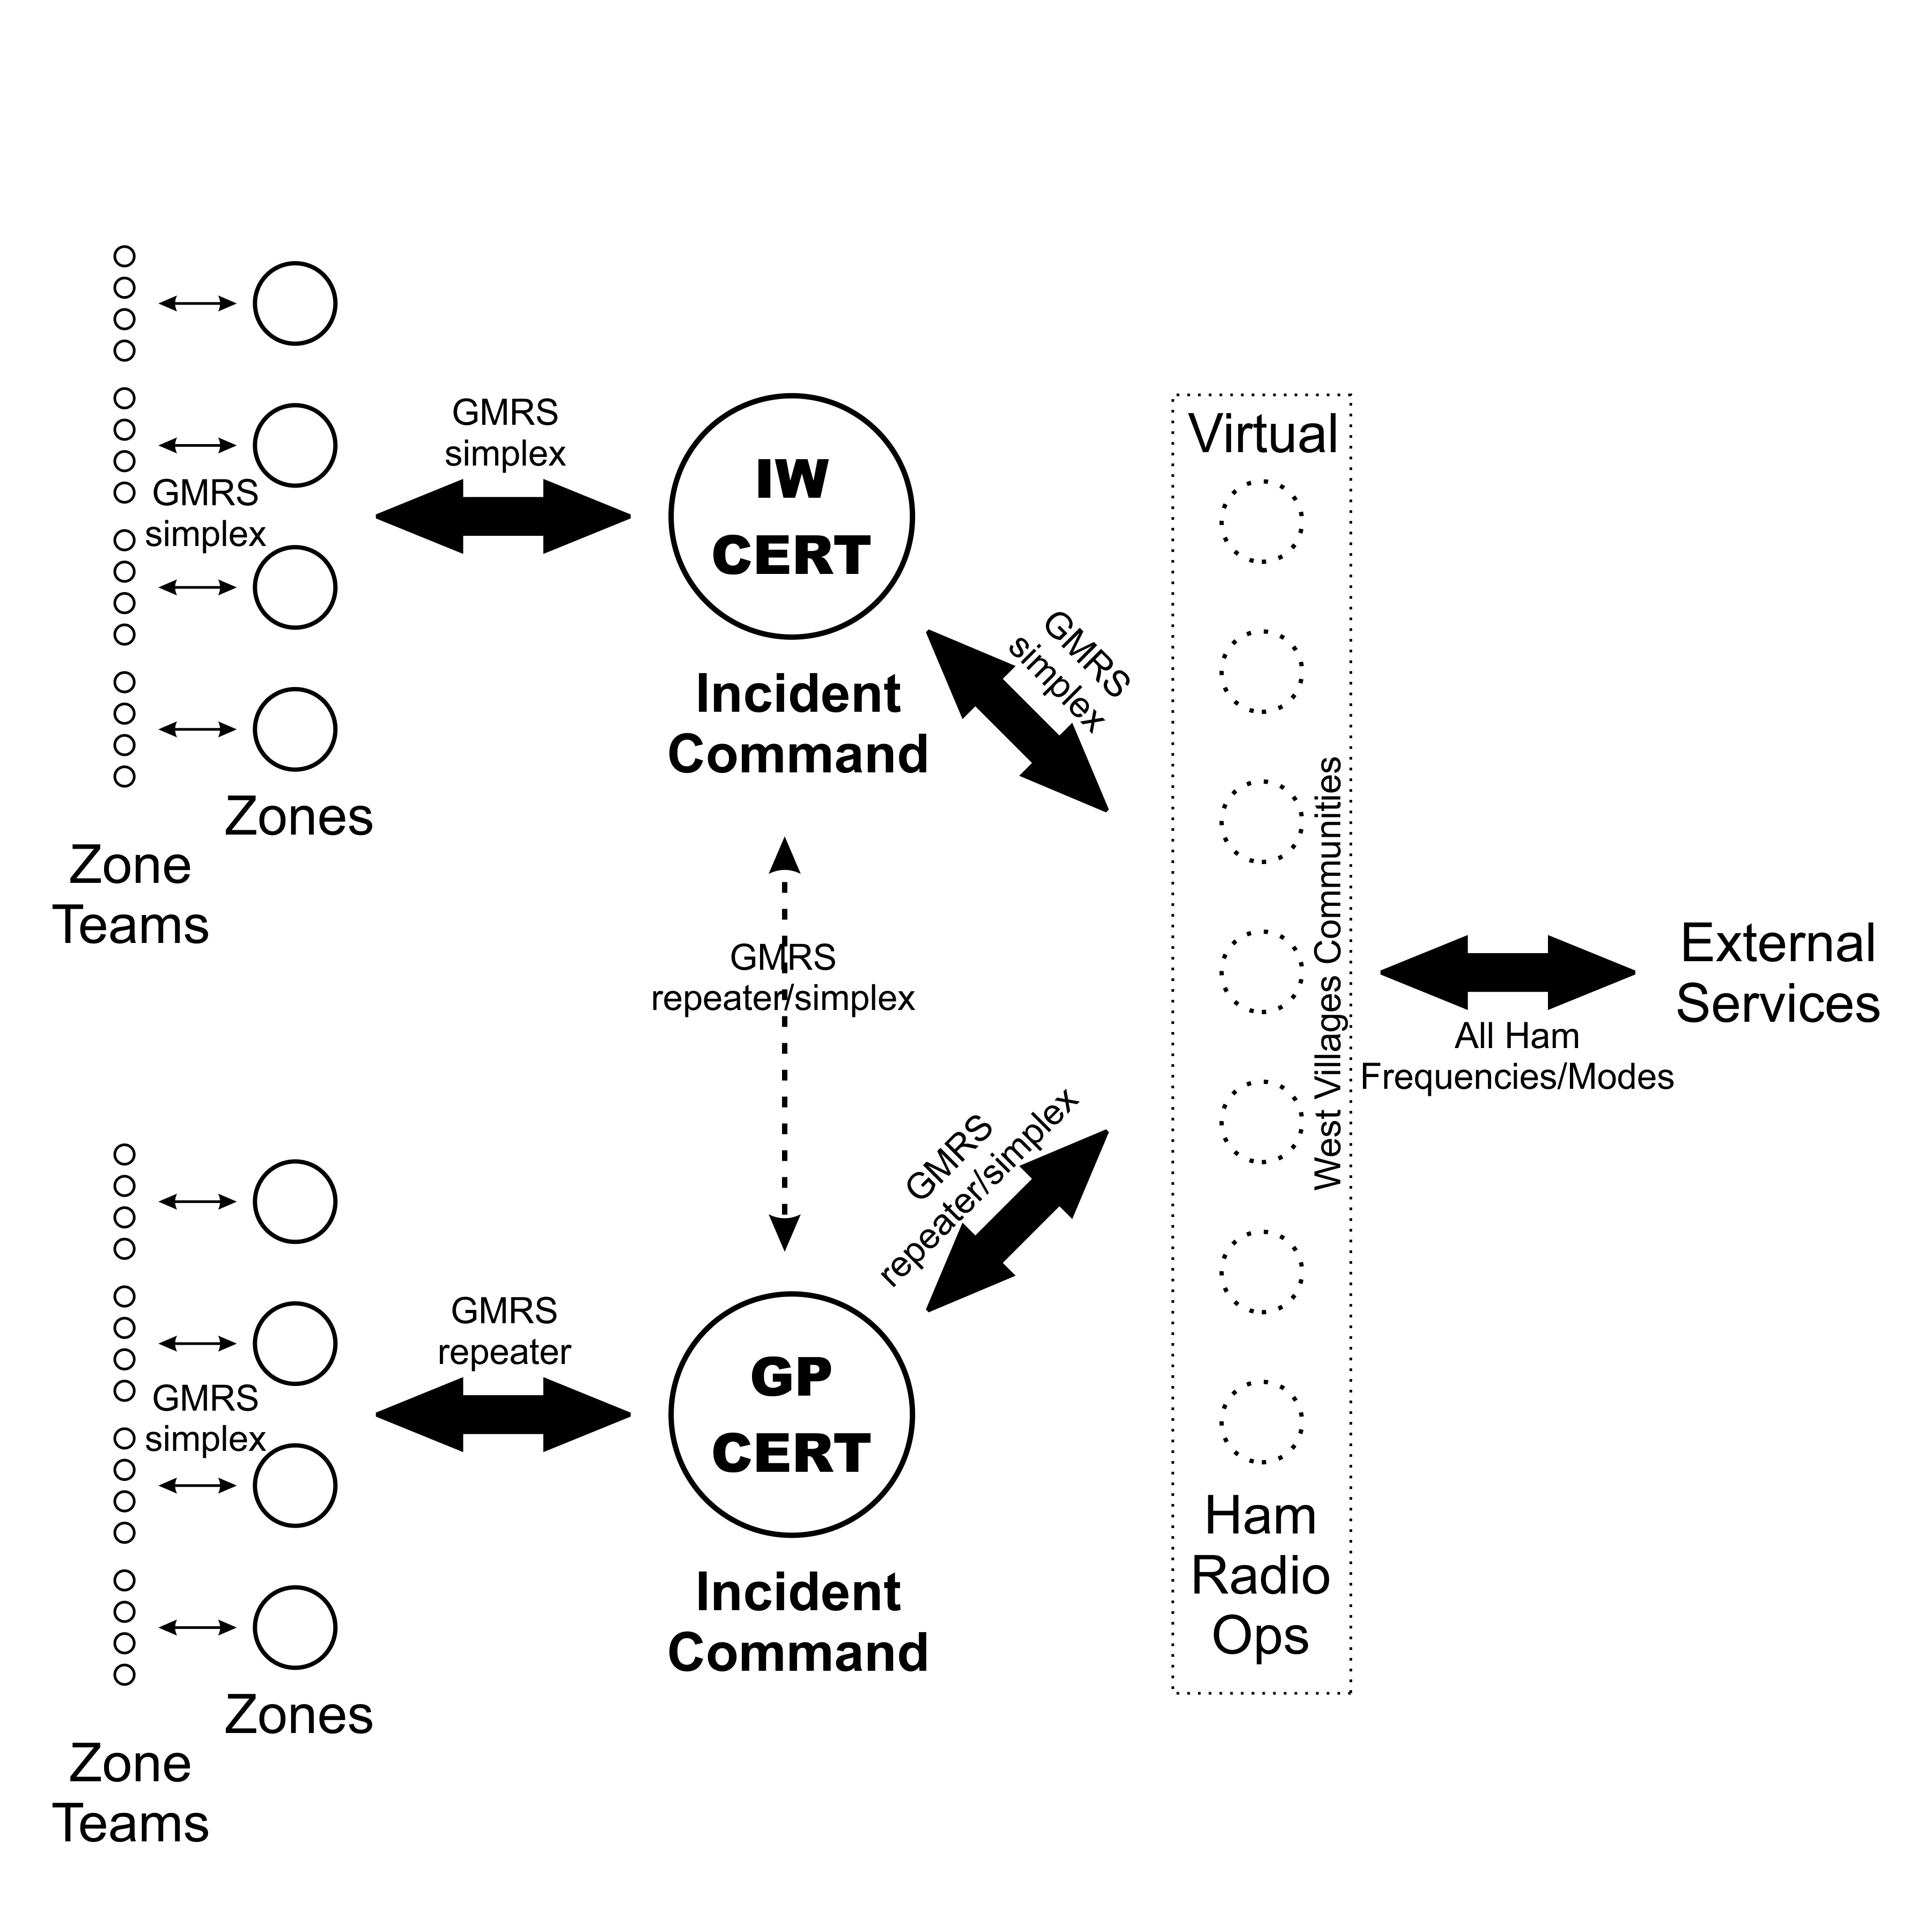

# **Effective Communications** – Repeater and Simplex

* Repeater Access is via channel 1 on the Retevis talkies (switch position 1)
* If the repeater is inoperable, use backup/simplex channel 2 on the Retevis talkies (switch position 2); this will NOT be very effective across the GP community and may require another zone member to relay a message to the IC
* Zone Members should always use their assigned channel, never Retevis channels 1 (repeater) or 2 (simplex) which are reserved for IC communications.
* Zone Leaders, Command Staff, Medical, Access Control, Comms are responsible for ensuring that their talkies are available to another team member when absent during an emergency or exercise
* **Listen**
  + Never speak over another, neither signal will be clear, communications may be blocked, *wait your turn*.
  + Wait for the repeater ‘tail’ (repeater noise) to drop in your talkie before speaking. You will then know that the channel is free.
* **Emergency essages have priority**
  + Say “Emergency” at the first opportunity to speak if the situation arises, all others stop speaking and wait for the emergency message to be passed.
* **Contacting Incident Command – wait for acknowledgement**
  + “Incident Command this is Zone 5, over”, wait for acknowledgement before passing your message; “Zone 5 (this is) IC, go ahead, over”, now pass your message, when message is complete say "Zone 5 clear”, this will alert others that the channel is open for other communications
* **Plan your message before speaking**
  + Speak clearly and stick to the point, keep message short and direct. The receiver will ask for more information if necessary.
* **Speak when spoken to, generally silence is golden, keep channel clear**
  + Unless you have something important to say, say nothing.
  + Always acknowledge a call “Zone 2 this is IC, over”, “IC this is Zone 2, over”, respond with info as necessary.

*Note:*

* *Communicating Simplex refers to communicating radio-to-radio direct, range is limited with CERT, FRS or GMRS radios. Intra-zone communications use simplex.*
* *The Family Radio Service (****FRS)*** *is a private, two-way, short-distance voice and data communications service for facilitating family activities that uses Ultra High Frequency (UHF) channels (~460MHz) and low power (½ watt output)*
* *General Mobile Radio Service (****GMRS)*** *is a licensed radio service that uses UHF channels (~460MHz.) .The most common use of GMRS channels is for short-distance, two-way voice communications using hand-held radios, mobile radios and repeater systems. Originally intended for business, now uses similarly to FRS.*

# 

# Frequencies Chart – FRS/GMRS

This chart is usefull for any CERT team member in order to program/operate their personal radios or to anyone wishing to listen to GP CERT activities.

|  |  |  |  |
| --- | --- | --- | --- |
| **Use** | **Retevis Channel** | **FRS/GMRS channel** | **Frequency (MHz)** |
| Incident Command  Repeater | 1 | 18 repeater, if available | Rx 462.6250  Tx 467.6250 |
| Incident Commander  Backup/Simplex | 2 | 18 | 462.6250 |
| Zone 1 | 3 | 1 | 462.5625 |
| Zone 2 | 4 | 2 | 462.5875 |
| Zone 3 | 5 | 3 | 462.6125 |
| Zone 4 | 6 | 4 | 462.6375 |
| Zone 5 | 7 | 5 | 462.6625 |
| Zone 6 | 8 | 6 | 462.6875 |
| Access Control | 9 | 7 | 462.7125 |
| Link to Islandwalk | 15 | 22 | 462.7250 |
| Simulated IC - EOC | n/a | n/a | 146.580 (ham freq) |

*Note: Not all FRS/GMRS radios can communicate/transmit thru a repeater*

# Ham Radio Stations

The number of ham radio operators within GP are extremely limited being fewer than 1% of the population. And, ham stations that can participate as CERT assistants on the necessary frequencies and modes are further limited. At any point in time there may only be 4-8 active hams able to participate in CERT. The real need is on the order of a dozen or so to account for those who leave the community during events and those otherwise available to cover 24 hour full or partial emergency shifts.

Due to the low numbers of hams available, Incident Command should NOT expect a ham to participate at the Command Center. Hams would be most capable when they are at their radio stations. A (non ham) dispatcher at the Command Center using the CERT repeater can relay messages to the ham station on call.

Island Walk has a similar situation as will all West Villages communities as they establish their teams.

Initially Island Walk and Gran Paradiso communications teams are developing a virtual set of ham stations, available via GMRS or ham frequencies to handle messages external to the respective communities.

# **GP ICS205 – Internal & External Comm Frequencies**

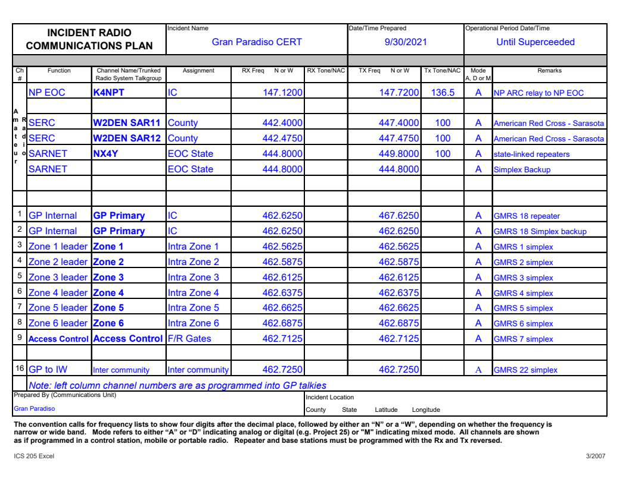*Note*

* *NP EOC has no Amateur Radio station, The K4NPT repeater may be used if available, use with caution*
* *SERC = Sarasota Emergency Radio Club (Amateur Radio),* [*www.n4ser.org*](http://www.n4ser.org/)*, connection to county to pass messages to Sarasota county EOC,* ***PRIMARY***
* *SARNET = Statewide Amateur Radio Networking,* [*www.sarnetfl.com*](http://www.sarnetfl.com/)*, connection to state to pass messages to Florida state EOC*